# Group

Amelia Lalla

Max

# Project Design

Mc: Female

Tile set: Bright Forestry, medieval stone/concrete/hut for buildings.

Enemies: monsters, Pokémon rip-offs.

NPC’s: Shop, Quest

Gameplay: Open world with a separate map for battles. Explore the open world, random enemies with random drops. Repeatable Quests.

Story: Lillia wakes up and looks around at her unfamiliar new surroundings. The last thing she remembers is drifting away while in Champ Select. She’d just locked in as Lilia, her namesake and new favourite champion, but somehow, she was here in a hut that smelt like piss and dried hay. She looked around while it dawned on her that she’d never seen hay and shouldn’t know what it smelt like.

As Lilia left the rickety shed that she woke up in she finds herself in a village that is completely new to her. Despite this she notices that she doesn’t feel uneasy or surprised in the least which is somehow more shocking than her new world. After spending some time in the village Lilia decides she’s had enough of this Alice in wonderland nonsense and make her way home…

# Image and Sprite Sheet for one enemy

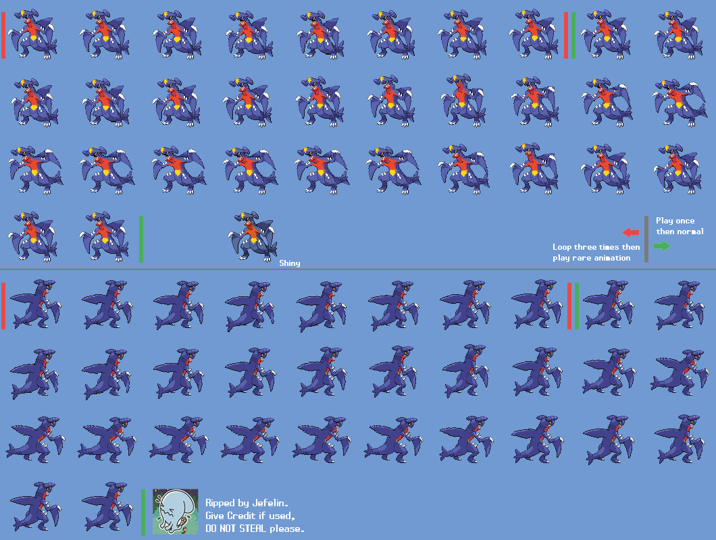

# Player Sprites

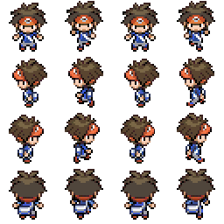

# Class Diagram

